LAB: Module 2 – Tips Splitter

In this lab, you will create a bill and tip splitter application. You will use basic layout controls and existing widgets to calculate the payment and tip amount for a restaurant bill.

# Part 1

1. Create a new Android application project named **RestaurantTipCalculator**.
2. Open the **main.xml** file (from the **res/layout** folder) and create the application UI using the visual designer or the XML editor, whichever feels more convenient to you.

Tip: To learn the most about how the visual designer changes affect the raw XML layout, compare the two views side-by-side while making your layout changes.

1. Add an **EditText** to retrieve the bill amount, a **TextView** to display the calculated tip, and a Button to trigger the tip calculation.
2. Write application event handlers and business logic in the **RestaurantTipCalculatorActivity** class. Your code should calculate the tip amount. At this time, use a hard-coded 12% tip percentage.

# Part 2

1. Add more views to the application such that the layout resembles the following:  
   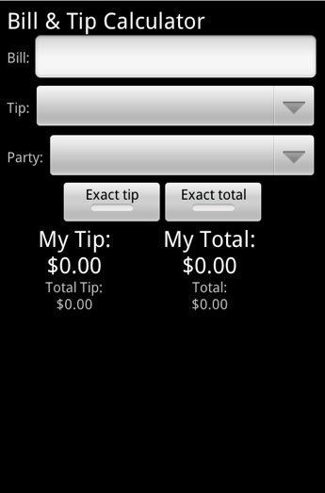
   1. In the above layout:
      1. The **Bill** text field receives the bill amount.
      2. The **Tip** and **Party** spinners provide a convenient way to define what percent of the bill should be tipped and how many persons should split the bill.
      3. The **My Tip** and **My Total** text fields are used to display calculation results. Every change in the input fields should update the displayed values.
   2. (OPTIONAL)Use the toggle buttons (**Exact/Rounded Tip** and **Exact/Rounded Total**) to enable rounding the amounts to the nearest dollar.
2. Add application strings and spinner values in the **strings.xml** file (from the **res/values** folder) and use them in your code-behind and in the UI layout.

Tip: Specifically, the spinner values can be stored as a string array and then converted to integers when performing the calculations.

1. The following is an example of how the finished application should appear after calculating a tip based on a $34.78 bill with a 12% tip and rounding.  
    